Potentials and Motion
Author: Dietmar Hiller (sagen@permondes.de)
Version: 11. December 2024
License: CC BY-NC-SA 4.0 (https://creativecommons.org/licenses/by-nc-sa/4.0/ )
Inhaltsverzeichnis
1. Introduction 1
2. Potentials 2
2.1. Gravitational Potential 2
2.1.1. Fields 2
2.1.2. Potential Energy 2
2.2. Other Potentials 4
3. Mathematical Basics 4
3.1. Coordinate systems 4
4. Classical Mechanics 5
4.1. Gravity 5
4.1.1. Comet on parabolic orbit 5
4.1.2. Geostationary Satellite 6
4.2. Gravity on Earth 7
4.2.1. Plane Pendulum 8
4.2.2. Rotating Pendulum 8
4.2.3. Example Ballistics without Air resistance 9
4.2.4. Example Ballistics with Air resistance 9
5. Electrodynamics 10
6. To investigate 10

Introduction
In classical physics forces and fields are used to describe the motion of an object. We tend to imagine e.g. an attractive force as an arm that pulls the object towards it. This image is natural to us because our history lies in classical mechanical considerations, but still, it is misleading. Also, this image does not make sense in magnetism nor in gravity. Instead of using this Newtons mathematics, the acceleration of a particle is understood here as the result of the gradient of an external potential. In classical mechanics it follows the simple rule: .
This is a classical approach, not a relativistic one in which "Gravity is generally regarded as part of the fabric of spacetime itself, ...[Spektrum der Wissenschaft 4.21, p. 12ff "Was ist ein Teilchen"]. However, the similarities between the potential approach and the spacetime fabric are remarkable.
This rule is extended for cases were e.g. friction is involved or were the mass is changing over time.
Examples are used to describe and test this approach. The visualization is done, where possible with the limited capabilities of the available device, using an analogue engine.
Dante Alighieri, Purgatorio 18:
Ogne forma sustanzïal, che setta
è da matera ed è con lei unita,
specifica vertute ha in sé colletta,
la qual sanza operar non è sentita,
né si dimostra mai che per effetto,
come per verdi fronde in pianta vita.
Jedwede Form des Daseins, die verschieden
Vom Stoff und dennoch mit dem Stoff verbunden,
Trägt in sich Sonderkraft, die ihr beschieden,
Die, unbetätigt, sich nicht lässt erkunden;
Wie durch sein grünes Laub der Baum sein Leben,
Kann sie allein durch Wirkung sich bekunden.

Potentials
In physics, the potential is the ability of a conservative force field to perform work. It describes the effect of a conservative field on masses or charges regardless of their size and sign.

Gravitational Potential

Fields
A mass modifies its surrounding space in such a way that other masses experience a force. Such a state is referred to as a field and due to the force effects as a force field. The field around a mass is called a gravitational field. A field can only be detected indirectly via the effect of its force.
Dante Alighieri, Purgatorio 18:
Ogne forma sustanzïal, che setta
è da matera ed è con lei unita,
specifica vertute ha in sé colletta,
la qual sanza operar non è sentita,
né si dimostra mai che per effetto,
come per verdi fronde in pianta vita.
Jedwede Form des Daseins, die verschieden
Vom Stoff und dennoch mit dem Stoff verbunden,
Trägt in sich Sonderkraft, die ihr beschieden,
Die, unbetätigt, sich nicht lässt erkunden;
Wie durch sein grünes Laub der Baum sein Leben,
Kann sie allein durch Wirkung sich bekunden.
The strength of the gravitational field is defined independently of a specific sample mass m_{p}, i. e. the force is normalized to this sample mass.
The gravitational field is equal to the acceleration of a small body m_{p} in the space around the massive object. It is the negative gradient of the gravitational potential. .

Potential Energy
If the field is conservative, i. e. W is independent of the path, it follows that each point r can be assigned a unique function Φ(r), the potential. The gravitational potential Φ at a distance x from a point mass M can be defined as the work W that needs to be done to bring a unit mass in from infinity to that point:

(2.1.2-1)
The physical observable in this equation is the work obtained by taking the difference of the potentials of the two positions. Therefore, nothing changes if an arbitrary scalar constant is added to all potential values. This constant is generally determined in such a way that the potential disappears at infinity: Φ(∞)=0.
The negative sign means that work is released.
The potential associated with a mass distribution is the superposition of the potentials of point masses. If the mass distribution is a finite collection of point masses, and if the point masses are located at the points x1, ..., xn and have masses m1, ..., mn, then the potential of the distribution at the point x is
(2.1.2-2)
If the mass distribution is given by the density of the distribution ρ(r), then the gravitational potential is the volume integral
(2.1.2-3)
ρ can be recovered using the Laplace operator:
(2.1.2-4)

As a consequence, the gravitational potential satisfies Poisson's equation.
[Physik für Bachelors, Johannes Rybach, Hanser Verlag] [Gerthsen Physik, Dieter Meschede] [Wikipedia, Gravitational_potential]
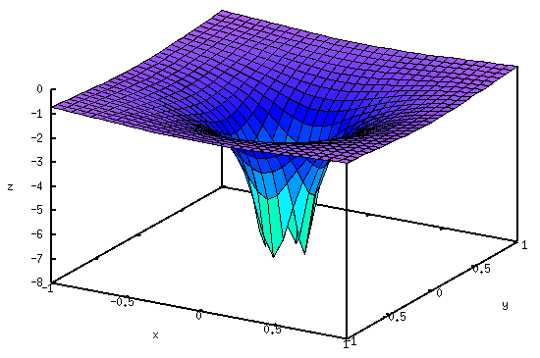
/* [wxMaxima batch file version 1] */
Gamma: 6.67408e-11;
M: 1;
r(x,y):=sqrt(x^2+y^2);
%Phi(x,y):=-(Gamma*M)/r(x,y)+%Phi[inf];
%Phi[inf]:0;
plot3d(%Phi, [x,-1,1], [y,-1,1], [z,-8,0])

Other Potentials
For other types of fields, the decomposition must be carried out differently, e. g. for the electrostatic field into the electric field strength and the charge e of the sample.
In general (not only for the field of a point mass), results from and the field strength results from the potential by gradient formation:

Mathematical Basics
The language of physics is mathematics, thus here some basics needed.

Coordinate systems

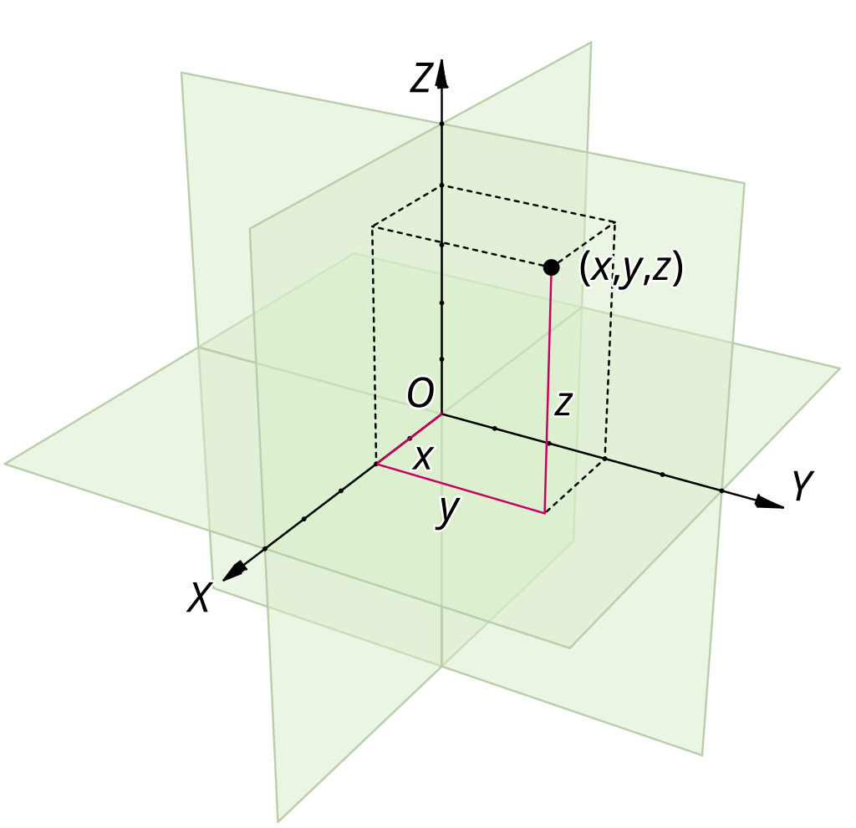
Cartesian coordinates
- Gradient: | (3.1-1)

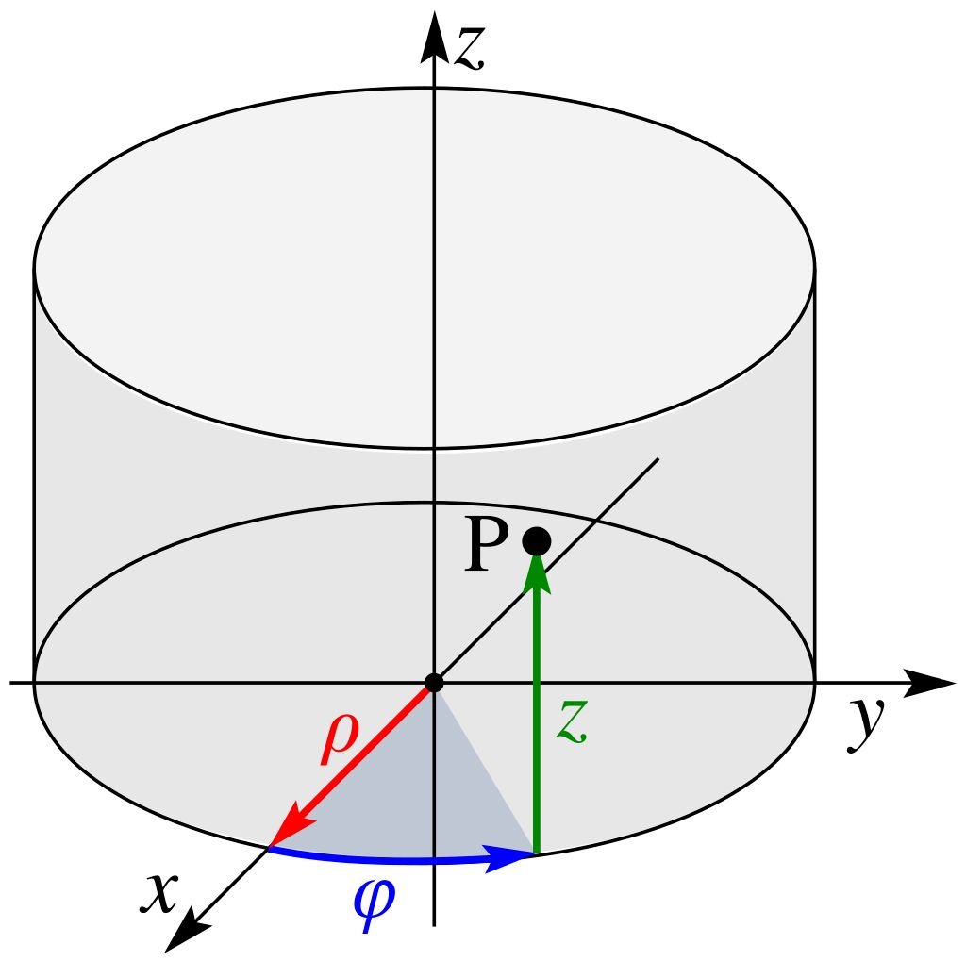
Cylindrical coordinate system
- Conversion: | (3.1-2)
- Gradient: | (3.1-3)
- Derivation: | (3.1-4)
[Wikipedia Zylinderkoordinaten, Polarkoordinaten]

Spherical coordinates
- Coordinates:
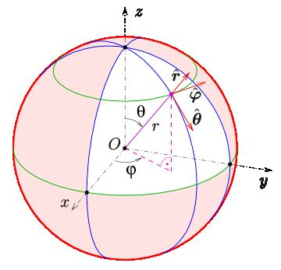
  - r: the radius, is the distance of the point P from the origin; this defines the spherical surface on which P is located.
  - θ or ϑ: the polar angle, is the vertical angle. On earth it points to the poles (ϑ=0) or the equator (ϑ=π/2) or in between.
  - φ, the azimuthal angle, is the horizontal angle. On earth it points along the equator.
- Conversion: | (3.1-5)
- Gradient: | (3.1-6)
- Laplace: | (3.1-7)
- Derivation: | (3.1-8)
[Wikipedia Sperical Coordinate System, Wikipedia Kugelkoordinaten]

Classical Mechanics

Gravity
A small mass m is located in the gravitional potential of mass M. It’s motion is given by
(4.1-1)
To be correct, we would have to consider additionally the effect of m on M as well, so that both masses are accelerated. However, here m « M is assumed, such as a sattelite close to earth.
Additionally we have the initial postion r₀ of mass m as well as its initial speed v₀.

Comet on parabolic orbit
A comet moves on a parabolic orbit in the gravitational field of the stationary sun. Its orbital plane coincides with the plane of the Earth's orbit, which is assumed to be circular. The perihelion distance is one third of the Earth's orbital radius R_{E}.
The acceleration in a gravitational potential is given by (4.1-1).
On the other hand, acceleration in polar coordinates is given in equation (3.1-4).
Putting both together gives .
Also we know the comet is moving on a parabolic curve . r_{PE} is the perihelion distance.
Differentiation gives

Next, the situation at the perhilion (φ=π) is investigated.
, as expected.
Because are definite,

.
Putting the two equations for together:

Summarizing the situation at the perhilion:

With these boundary conditions and the differential equations for r and φ the problem can be solved.

Geostationary Satellite
A satellite is always located over the same point above the surface of the earth. Where is it located?
As spherical coordinates are being used, the starting point for the acceleration is equation (3.1-8). This acceleration is equal to that given by the potential field of earth (4.1-1). Separating the three coordinates results in the following set of equations:

These equations are rewritten in order to have the highest derivative on one side:

This set of equations is valid in general.
First, we require the satellite to remain on the same altitude r:

Next, we have , with ωE the rotation of the earth: . This requires the term in brackets to be equal to zero. Thus and/or θ=π/2.
The first condition gives .
The second equation is true for θ={0, π} (sin θ), which however requires from the first equation that r=∞, so the satellite is over one of the poles at infinite distance, or again that θ=π/2 (the satellite being over the equator). This gives

In numbers

Gravity on Earth
Prerequisites:
- assume that the mass point m is positioned close (at height h) above the earth's surface M.
- the center of the earth is the coordinate origin
Thus r = R (radius of the earth) + h, with h << R.
The potential can be written as:
(4.2-1)
Thus the acceleration is
(4.2-2)

Plane Pendulum
The mathematical pendulum or plane pendulum is an idealized pendulum. In such a pendulum, an imaginary point-shaped mass suspended from a point by means of a massless pendulum rod can swing back and forth in a vertical plane, whereby frictional effects, in particular air resistance, are neglected.
Using polar coordinates, the acceleration is in general given by equation (3.1-4). In this application, the length of the pendulum r is constant.
On the other hand, earth gravity is given by , using the conversion (3.1-2).
Comparing the components in the two directions gives

The first equation does not provide a physically valid solution whereas the second equation describes the motion of the pendulum.
For small angles φ it can be approximated using the first order Taylor series to , the equation for the harmonic oscillator.

Rotating Pendulum
A pendulum is rotating with constant angular speed and without friction. What are its dynamics?
As the motion can be seen as a circle on a sphere, spherical coordinates are used. The acceleration is given by equation (3.1-8).
In this case we have the following boundary conditions:
- length of pendulum r=constant, thus ṙ=ṙ̇=0
- angular speed is constant, thus φ̇̇̇̇͘͘=0
- the vertical angle ϑ remains constant, thus ϑ͘=ϑ͘˙˙=0
This simplifies the equation to .
Gravity has the form , which is expressed in spherical coordinates with equation : . Comparing the 2 components for e_{r} and e_{ϑ} provides the following equations:

The first equation can only be true for an angle of π/4, the second equation provides , which includes also the angle of π/4. The polar angle only depends on the length of the pendulum and the rotation speed (and of course g).

Ballistics without Air resistance
The acceleration on earth is given by (4.2-2). Thus speed and position are calculated by

Ballistics with Air resistance
Resistance is not taken into account as force but as negative acceleration. Air resistance reduces the acceleration that the body experiences due to the gradient of the potential field.

In laminar flow, the flow resistance is only caused by the internal friction of the medium. If η is the dynamic viscosity of the medium, then for spherical bodies of mass m of radius r the pure dependence of the flow resistance on the velocity applies, the empirically determined Stokes' law is [Wikipedia Strömungswiderstand] .
Through the value acting against the acceleration becomes
.
Thus the differential equation is
.

Example: Floating sphere
An air flow from below is to be adjusted so that a sphere floats in it.

It is therefore sufficient to consider only the vector e_{r}.

Electrodynamics

To investigate
Investigate the following applications how they can be described using a purely potential field approach:
• 3.3 Harmonic Oscillator:
◦ 3.3.2 Damped,
◦ 3.3.3 Hollow Cylinder,
◦ 3.3.4 Bead glides on cycloidic wire,
◦ 3.3.5 Longitudinal Oscillating Chains:
▪ a) Masses hanging on springs,
▪ b) Two masses fixed to walls,
▪ c) Linear Molecule,
▪ d) Example CO2
• 6: Electrodynamics:
◦ 6.1 Mass with charge in em field
- Potential theory as starting point: https://en.wikipedia.org/wiki/Potential_theory

